**Uploading Image Data to the Azure Storage Accounts**

**Introduction:**

Fabrikam has been using and testing the Azure services for adaptation. They are now looking for using Azure Storage Account for storing their semi-structured data. The team is going to perform an operation where they can deploy the Azure Storage Account via Azure Cloud Shell CLI. Followed by the deployment, they are also going to deploy the container inside the storage account and upload a blob file into it. SInce they might have to call a few datasets from external sites, the team will be deploying an Azure WebApp and will be hosting a sample site in it. The object data that is in the container will be pulled by the sample application that is hosted in the Azure WebApp service. If this works fine, Fabrikam is going to make use of the Azure Blob Storage service for managing and maintaining all their semi-structured data in the Azure Blob storage account which can be fed as an input to the other services of Azure in which analytics can be performed.

**Pre-requisites:**

1. Azure Subscription
2. Knowledge on Azure CLI
3. Understanding about Azure Storage

Log-in to Azure portal with your account using [www.portal.Azure.com](http://www.portal.azure.com). In Azure portal start a bash session.

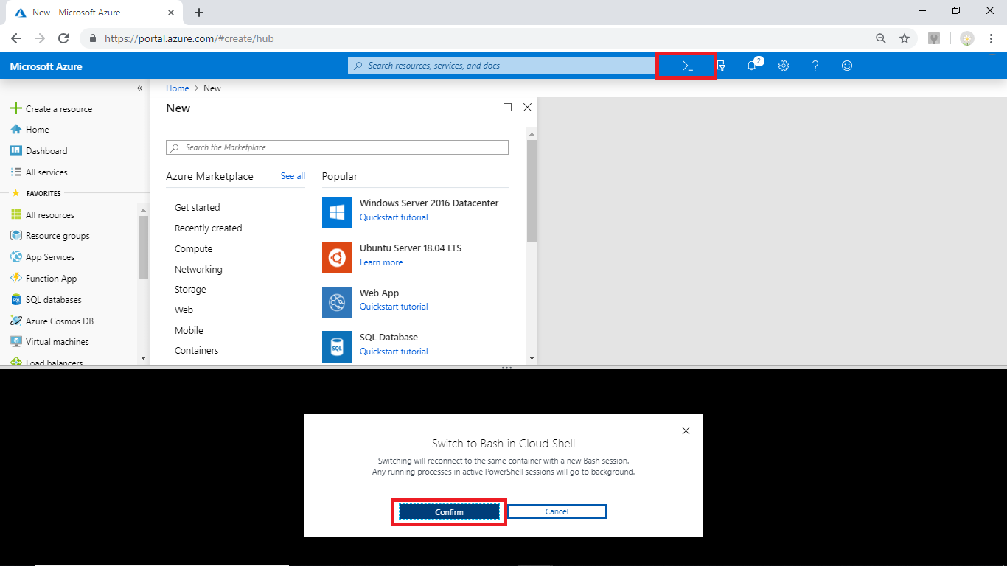

az group create --name fabrikam-Rg --location southeastasia

Run the following command to create a resource group.

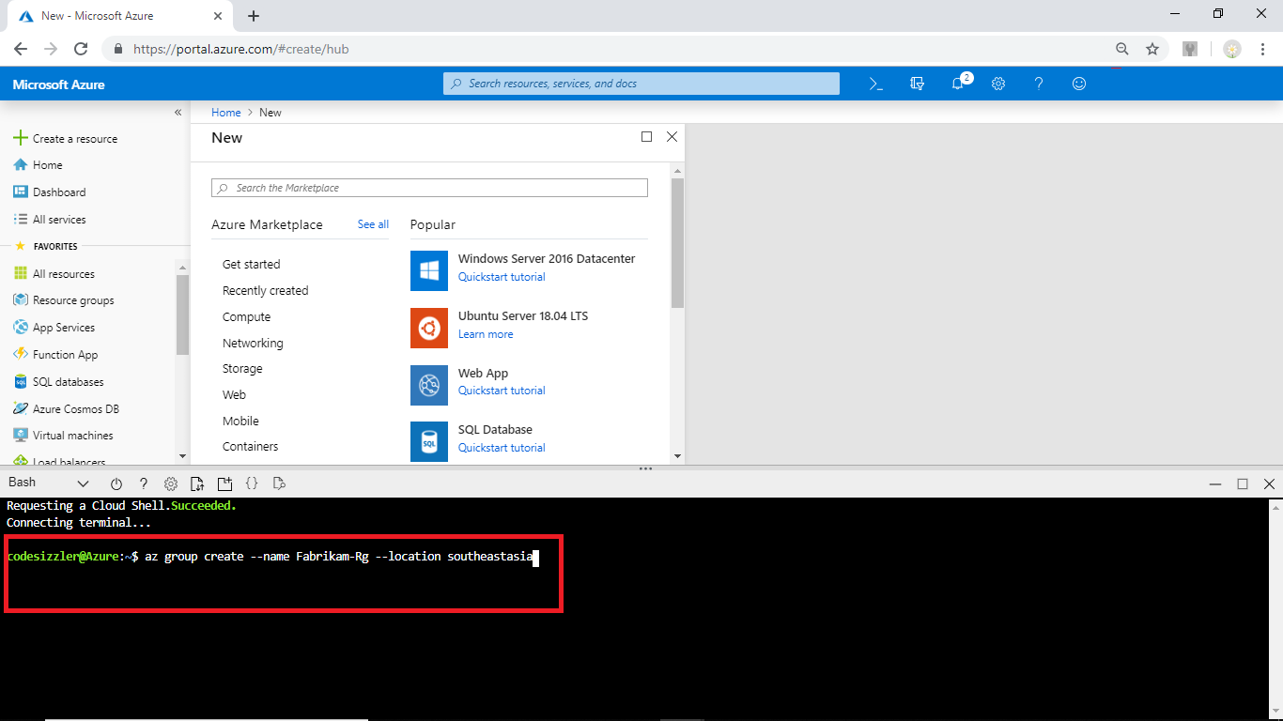

To create a Storage Account run the following command by replacing the respective values with your values.

blobStorageAccount=1fabrikamstorageaccount

az storage account create --name $blobStorageAccount \

--location southeastasia --resource-group Fabrikam-Rg \

--sku Standard_LRS --kind blobstorage --access-tier hot

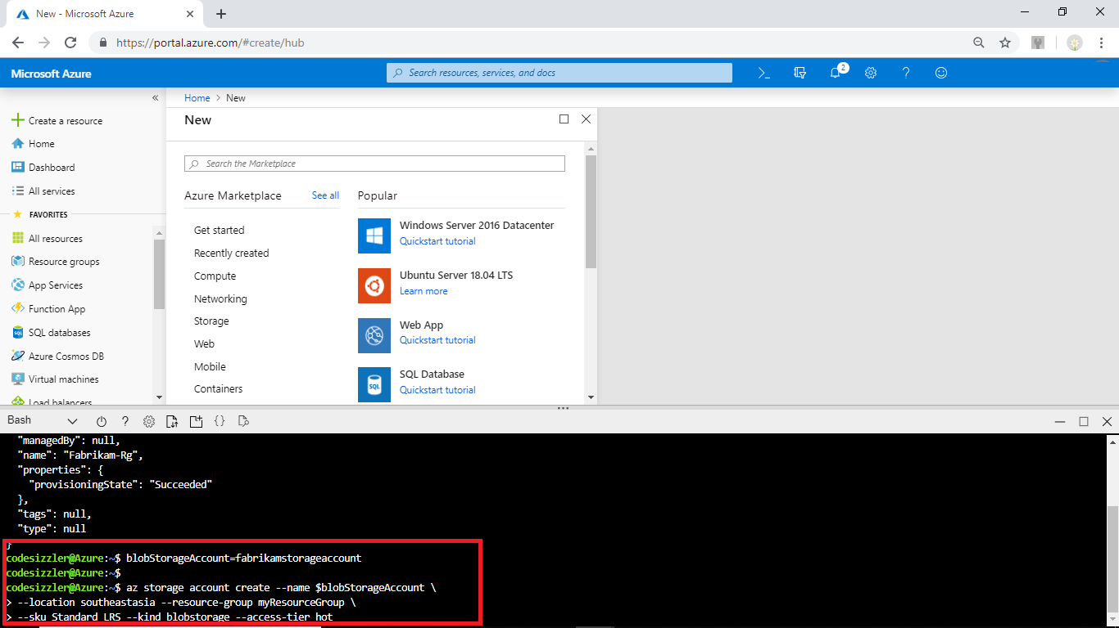Create a containers folders and store blobs and find the key value of Azure Storage account by running the following commands.

blobStorageAccountKey=$(az storage account keys list -g Fabrikam-Rg \

-n $blobStorageAccount --query [0].value --output tsv)

az storage container create -n images --account-name $blobStorageAccount \

--account-key $blobStorageAccountKey --public-access off

az storage container create -n thumbnails --account-name $blobStorageAccount \

--account-key $blobStorageAccountKey --public-access container

echo "Make a note of your Blob storage account key..."

echo $blobStorageAccountKey

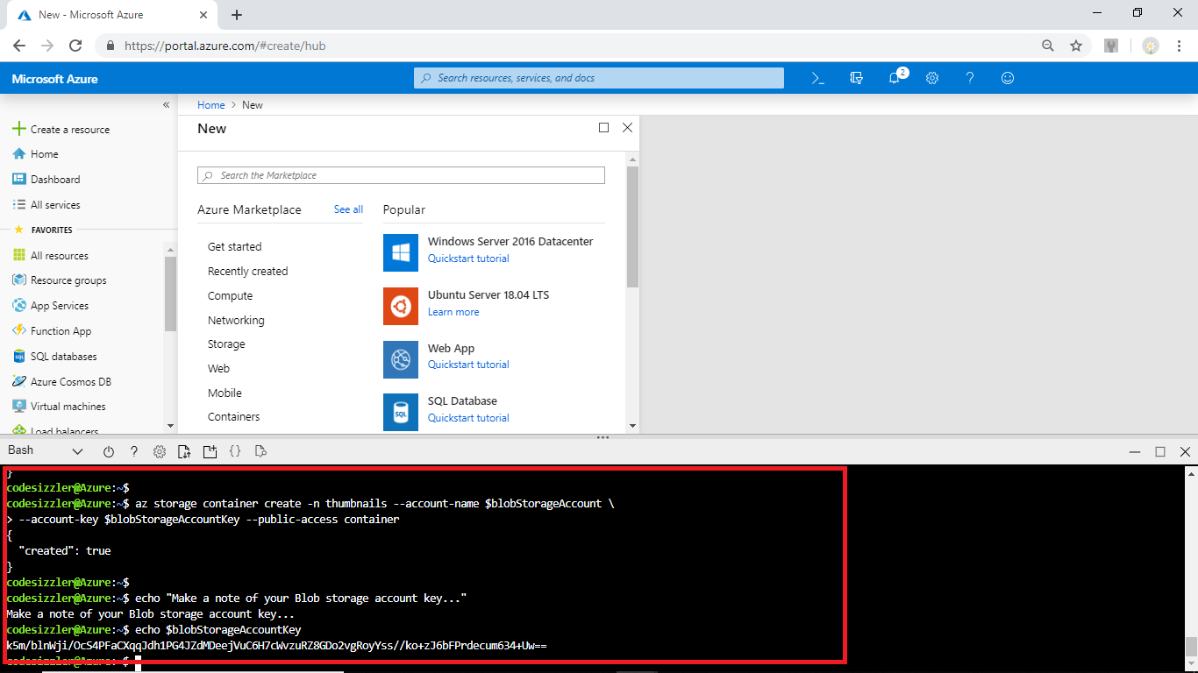

To create an App Service plan run the following command.

az appservice plan create --name FabrikamAppService --resource-group Fabrikam-Rg --sku Free

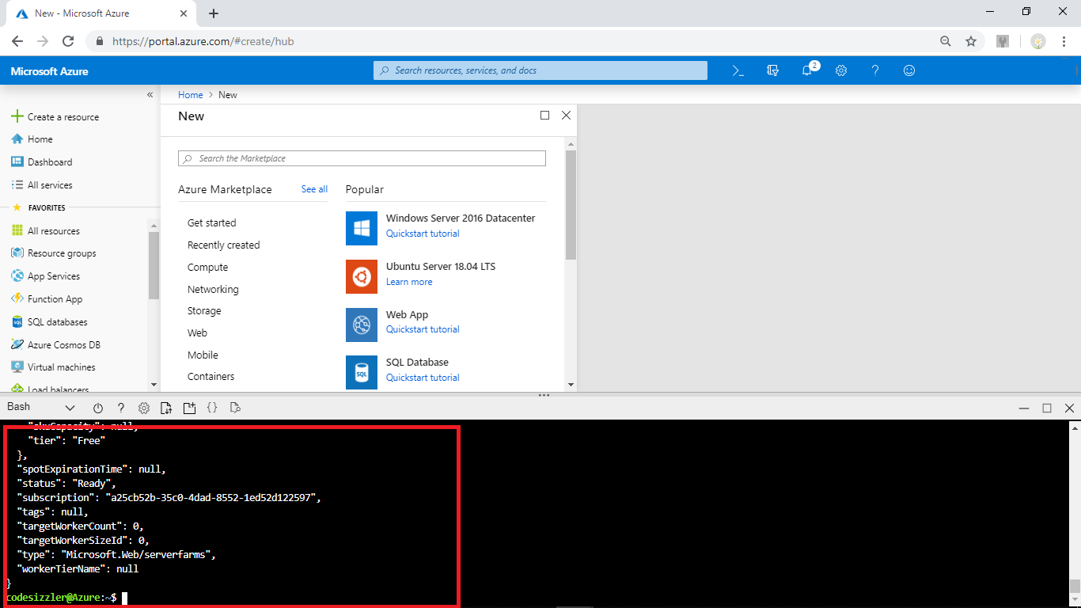

## Create a web app

Create a Web App with the previously created App Service plan by running the following command.

webapp=fabrikamwebapp

az webapp create --name $webapp --resource-group Fabrikam-Rg --plan FabrikamAppService

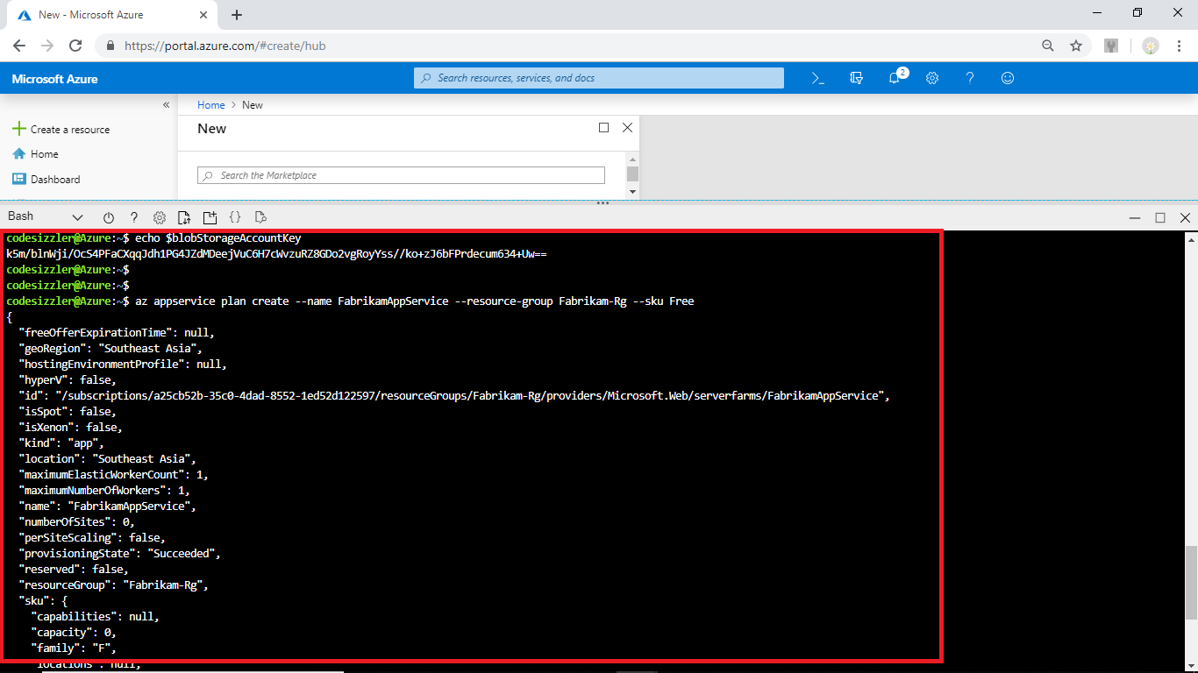

## Deploy the sample app from the GitHub repository

Configure GitHub deployment to the web app by running the following command.

az webapp deployment source config --name $webapp \

--resource-group Fabrikam-Rg --branch master --manual-integration \

--repo-url https://github.com/Azure-Samples/storage-blob-upload-from-webapp

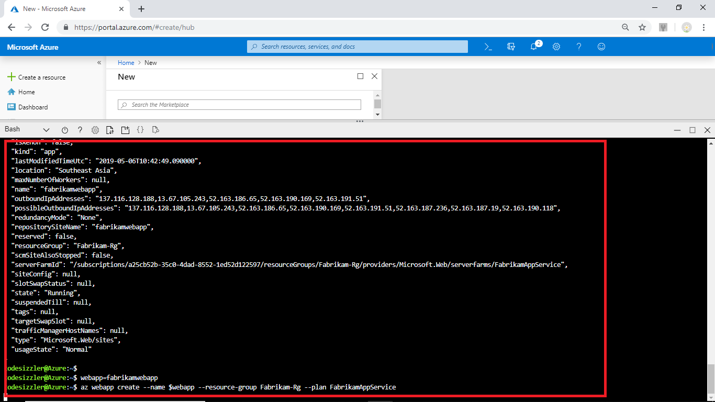

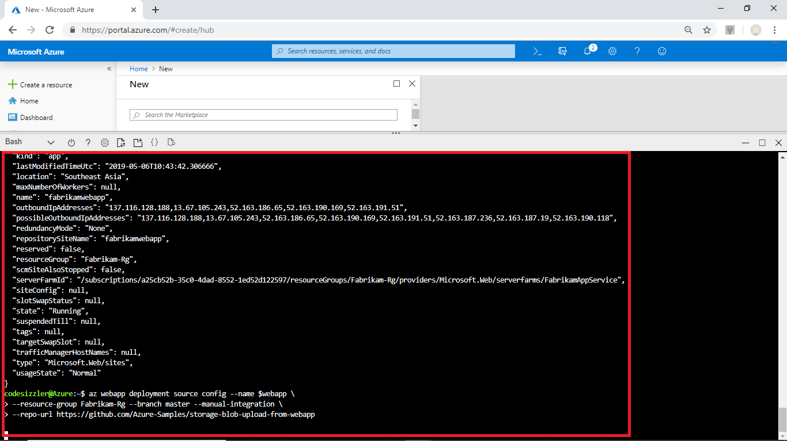

## Configure web app settings

Run the following command to configure the Web App settings.

az webapp config appsettings set --name $webapp --resource-group Fabrikam-Rg \

--settings AzureStorageConfig__AccountName=$blobStorageAccount \

AzureStorageConfig__ImageContainer=images \

AzureStorageConfig__ThumbnailContainer=thumbnails \

AzureStorageConfig__AccountKey=$blobStorageAccountKey

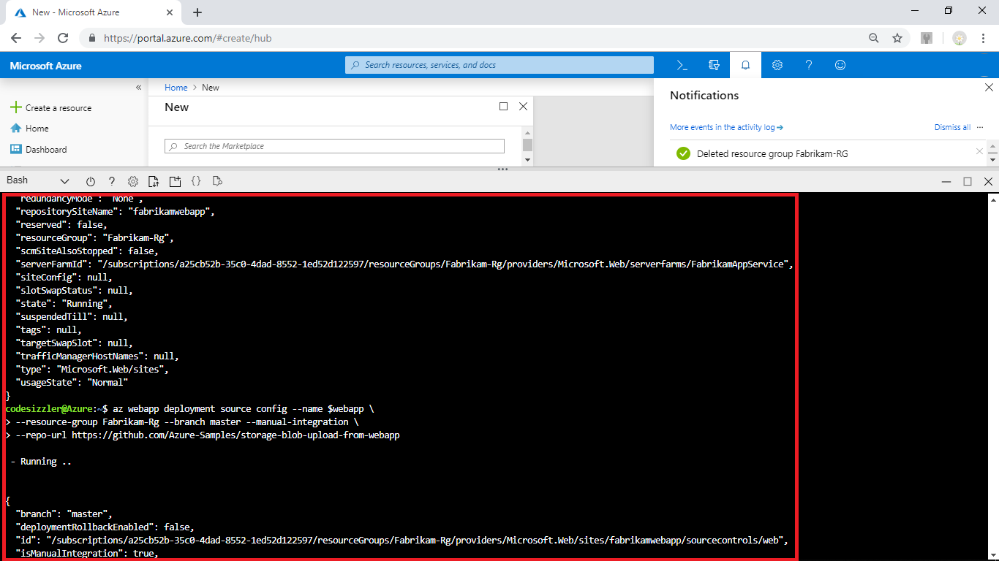

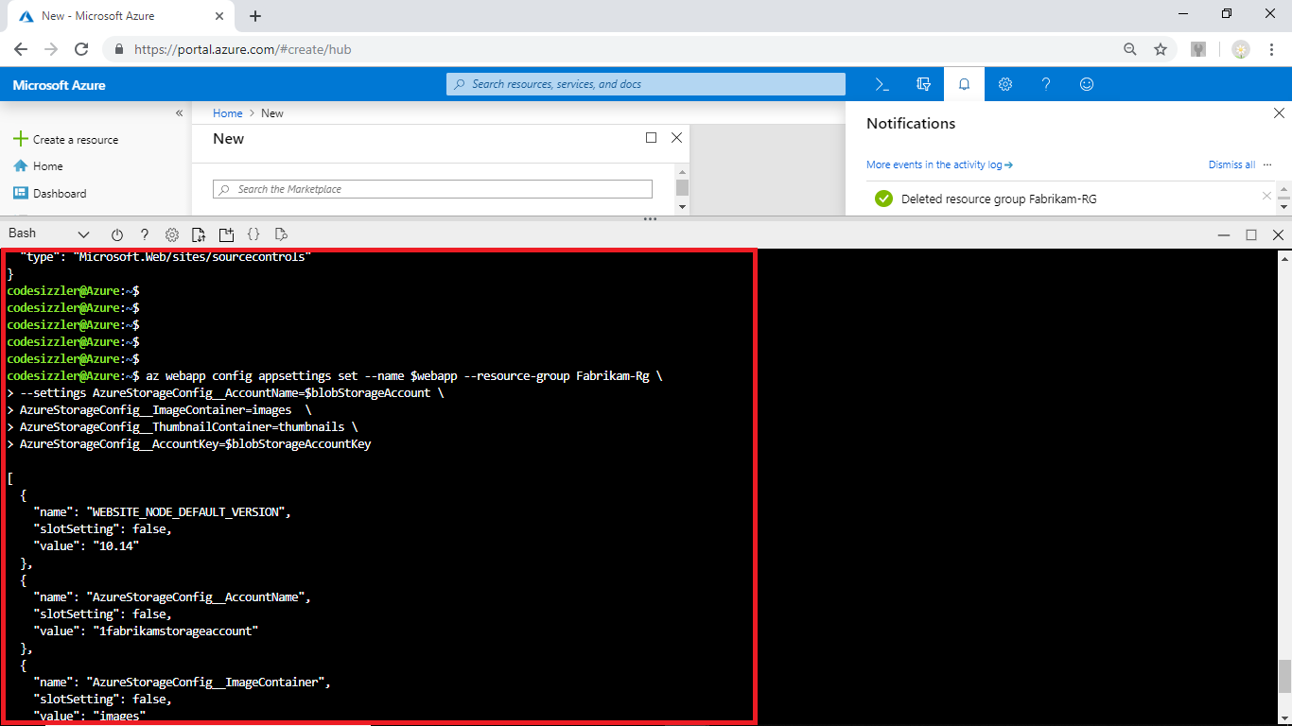

## Upload an image

Navigate to the created web app and copy the Web App URL. Open a browser and browse with the copied URL to upload an image.

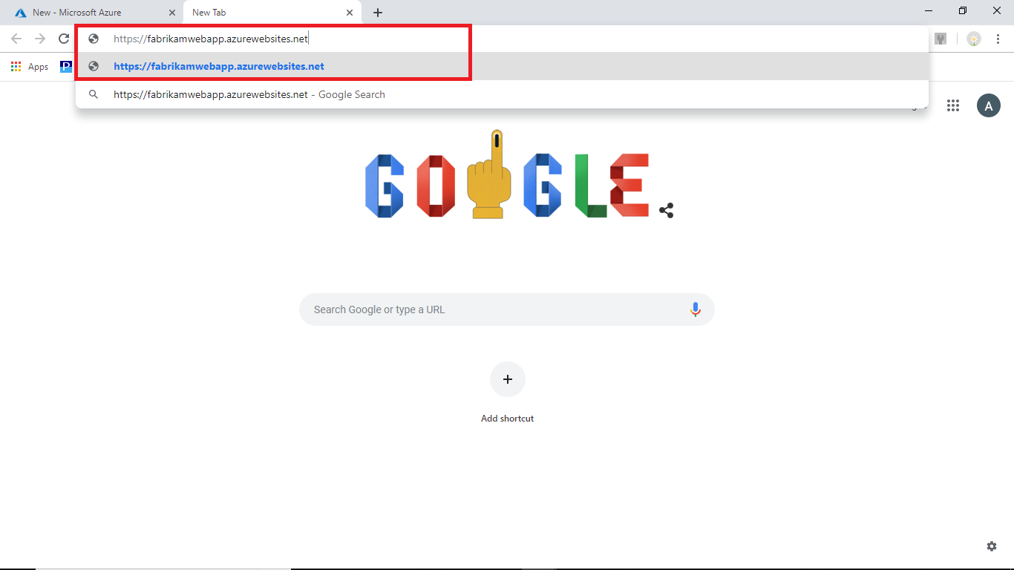

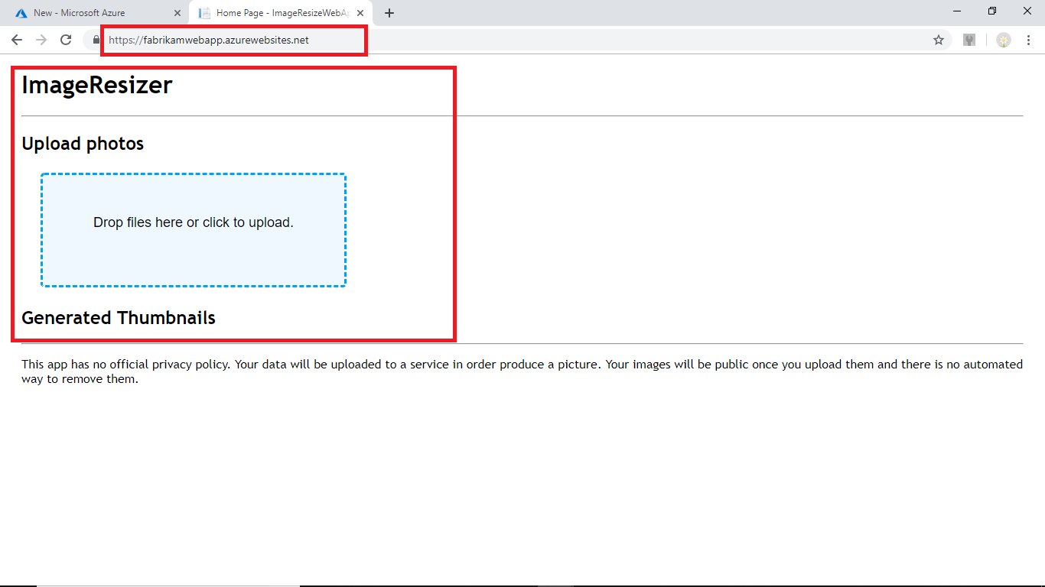

**Summary:**

Fabrikamis now clear that they will be able to make use of Azure Blob Storage for maintaining their Semi-structured data for feeding it as input to Azure Analytical services. With this successful execution, the team will be using Azure Storage Accounts for maintaining all their object data. Now, they are in hunt for CLI environment using which they can perform management operations over their object data. The team has found that AZCopy will be a suitable option for them and they are in the process of using it to work with Azure Storage Account.